SINE AND COSINE QUESTIONS
OCR GSCE – Thursday 5 November 2020 – Paper 5 (Non-Calculator) Higher Tier
1.
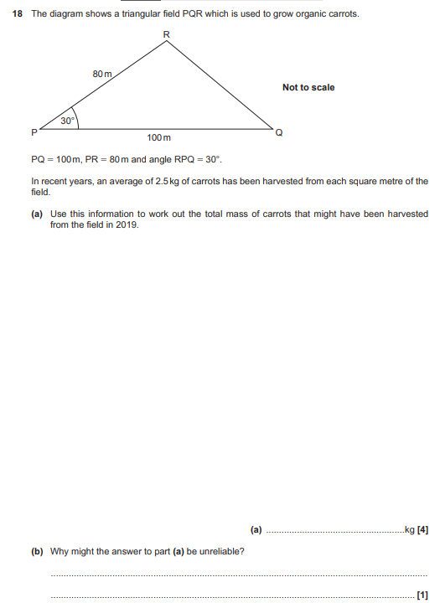

OCR GSCE – Tuesday 5 November 2019 – Paper 6 (Calculator) Higher Tier
2.
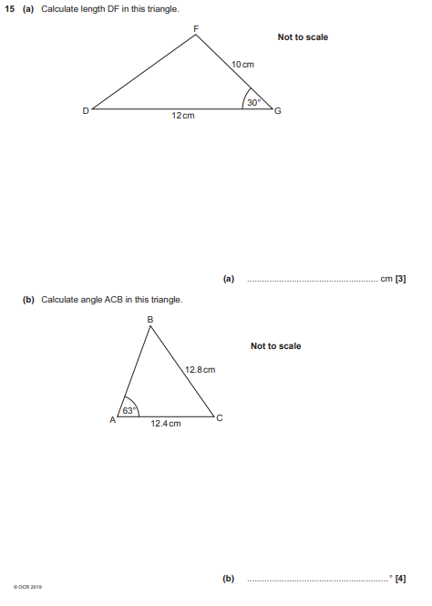

OCR GSCE – Thursday 8 June 2017 – Paper 5 (Non - Calculator) Higher Tier
3.
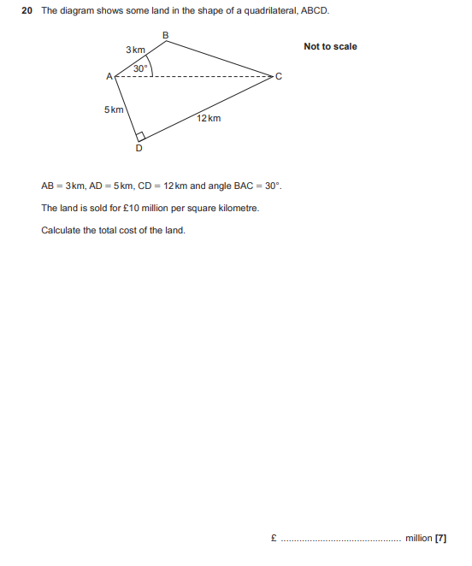

AQA GSCE – Thursday 6 June 2019 – Paper 2 (Calculator) Higher Tier
4.
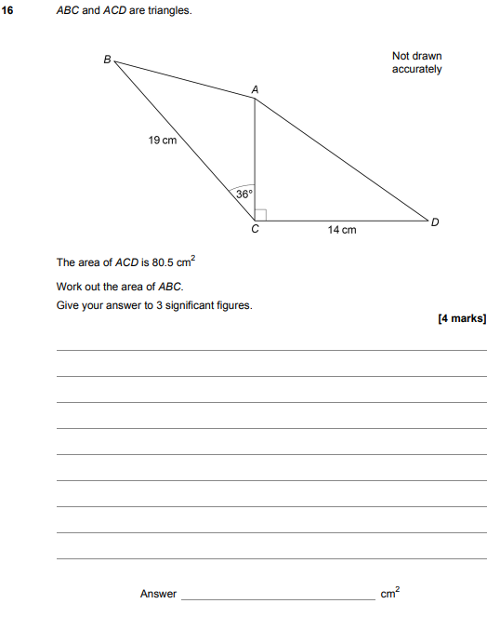

AQA GSCE – Tuesday 6 November 2018 – Paper 1 (Non - Calculator) Higher Tier
5.
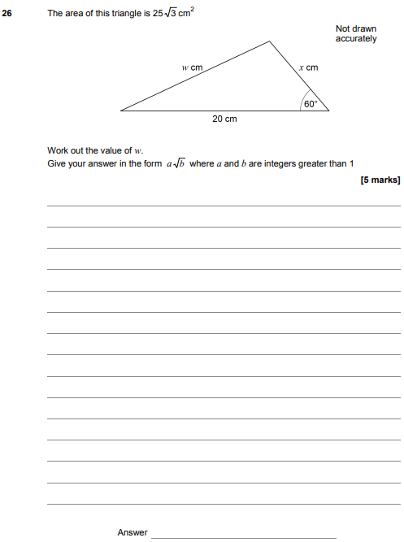

AQA GSCE – Monday 24 May 2018 – Paper 1 (Non - Calculator) Higher Tier
6.
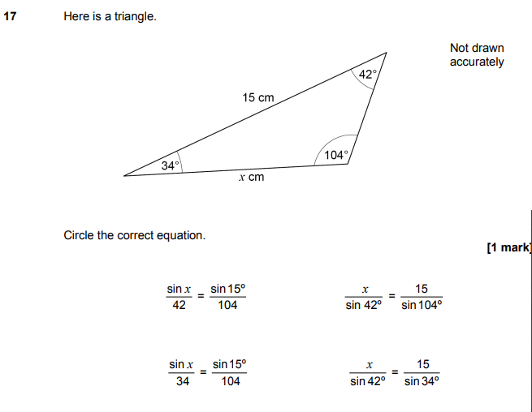

AQA GSCE – Thursday 6 November 2017 – Paper 2 (Calculator) Higher Tier
7.
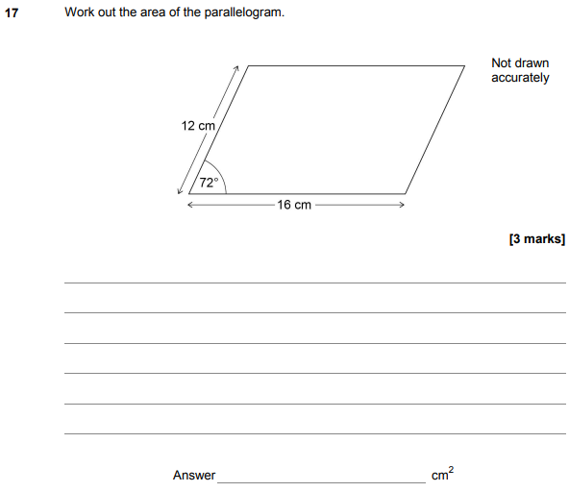

AQA GSCE – Wednesday 8 November 2017 – Paper 3 (Calculator) Higher Tier
8.
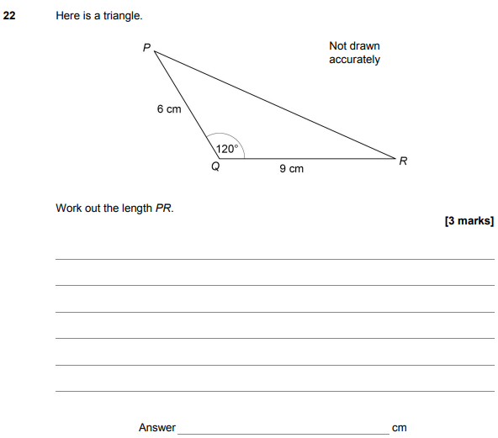

AQA GSCE – Thursday 8 June 2017 – Paper 2 (Calculator) Higher Tier
9.
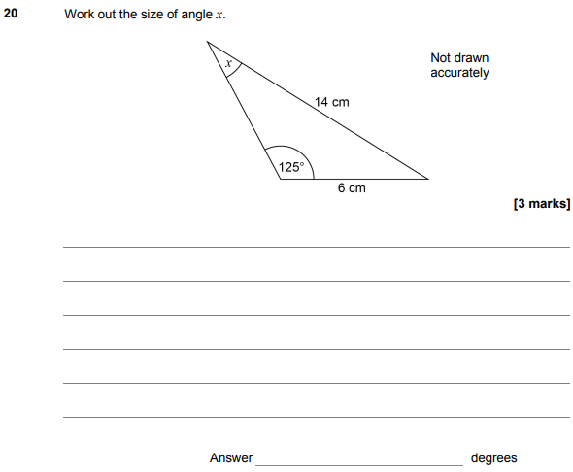

AQA GSCE – Sample Paper 2 (Calculator) Higher Tier
10.
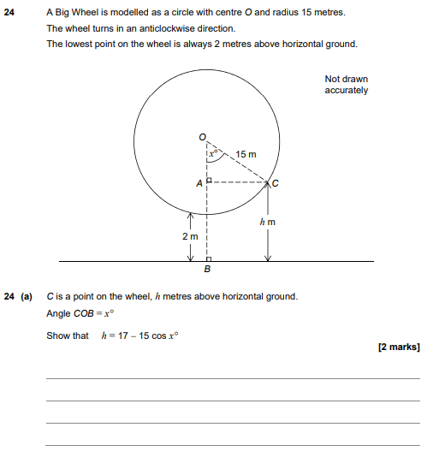
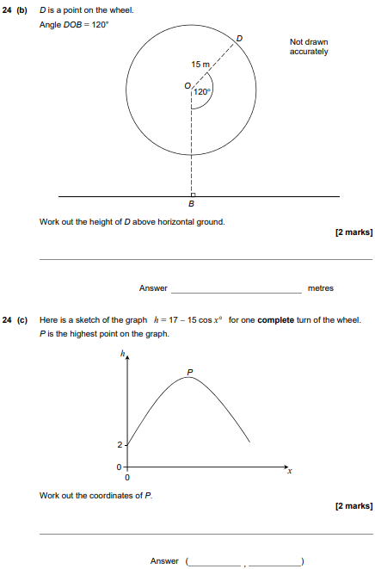

AQA GSCE – Sample Paper 3 (Calculator) Higher Tier
11.
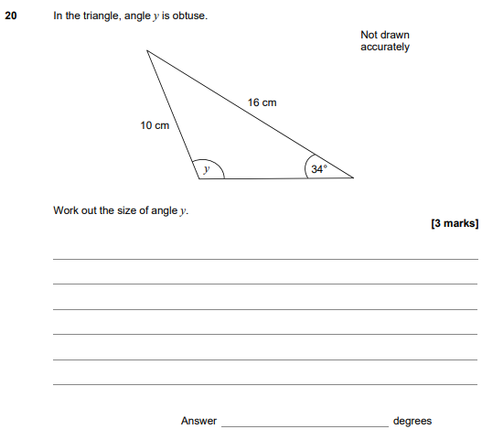
AQA GSCE – Sample Paper 3 (Calculator) Higher Tier
11.
